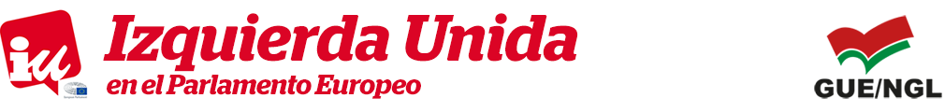

PRESS RELEASE
Couso demands that the EU stands “firmer” against Turkey concerning the proceedings against PIE Vice-President Maite Mola

Brussels, 21 March 2016

On Monday, the European Left MEP Javier Couso demanded that the EU be “firmer” with Turkey due to the proceedings initiated against the Vice-President of the Party of the European Left, Maite Mola, on whom they intend to apply the anti-terrorism law for having taken part in a peaceful demonstration in Istanbul against the Law on National Security approved by Prime Minister Ahmet Davutoglu’s government.

Couso’s reaction follows on from the response given by Johannes Hahn, the Commissioner for European Neighbourhood Policy, when asked in parliament about Mola’s situation.
Hahn acknowledged that the new Turkey legislation “does not fit in with the jurisprudence of the European Court of Human Rights” and assures that the European Commission “will ask Turkey to re-launch their reform process urgently, complying with the European norms on the Rule of Law, democracy and fundamental rights”.

The Vice-President of the European Parliament Foreign Affairs Committee revealed himself “outraged” with this “double standard” shown by the European institutions when handling Turkey. Courso said that on the one hand “we’ve just witnessed how the EU outsources the deportation of refugees to a country that does not respect human rights and therefore is not a safe country” and, on the other, “we see how the European Commission recognises that Turkey does not meet the minimum international democratic standards”. “One should ask what is being judged here”, he stated.

Hahn also assures in his response that “as far as the matter at hand is concerned”, i.e. Mola, “the EU delegation in Ankara can attend the hearings if it receives pertinent information on the details of the matter”. For the EL MEP, this is “not enough, not by a long shot”. “The European Commission acknowledges in its response that Turkey is not a safe country for any opponents, it’s not safe for the Curds, it’s not safe for the press and it’s not safe for the Vice-President of a European party” he said.

He further reclaimed that “we demand that the EU be firmer with Turkey and does not restrict its legal assistance to Maite Mola, but also offer legal advisory services and diplomatic pressure”.

Mola and another ten people demonstrated in Istanbul in February 2015 against the repressive Turkish gag law that the parliament would approve one month later. They were charged with insulting President Recep Tayyip Erdogan using a banner. In November, a group of more than 40 MEPs signed a letter supporting the Vice-President of the EL, demanding that the High Representative of the European Union for Foreign Affairs and Security Policy, Federica Mogherini, mediate with Ankara in order to curb the legal proceedings.

